

一、查找黄色区域：

rgb=[255,255,0]

if(abs(color_rgb(1)-R)<35&&abs(color_rgb(2)-G)<35&&abs(B-color_rgb(3))<200)















二、 确定中值滤波m值

1. m = 3的，中值算法



1. m = 5， 中值算法



1. m = 8， 中值算法



1. m = 10 ， 中值算法



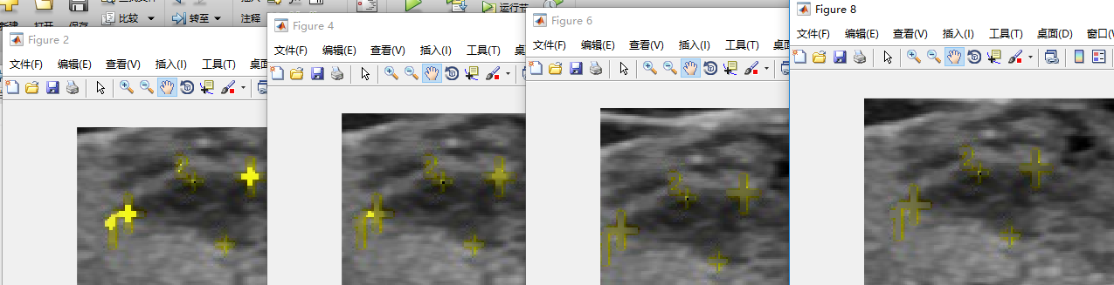

clear all;

image = imread('80001.bmp');

figure,imshow(image),title('Original Image');

%bw=imbinarize(image,0.3);

%figure,imshow(bw),title('Gray Image');

rgb=[255,255,0];

img=extract_rgb(image,rgb);

figure,imshow(uint8(img)),title('Repaired Image');

function [out_img] = extract_rgb(in_img,color_rgb )

%UNTITLED2 Summary of this function goes here

% in_img ÊäÈëÍ¼Ïñ color_rgb ÐèÒª·Ö¸îµÄrgbÏñËØÖµ

% ÌáÈ¡RGB²ÊÉ«Í¼ÏñÖÐµÄÄ³Ò»¸öÑÕÉ«

[rol, row,mut]=size(in_img);

out_img=zeros([rol,row,3]);

m=10;

for x=m+1:(rol-1-m)

for y=1+m:(row-1-m)

R=in_img(x,y,1);

G=in_img(x,y,2);

B=in_img(x,y,3);

if(abs(color_rgb(1)-R)<35&&abs(color_rgb(2)-G)<35&&abs(B-color_rgb(3))<200)

out_img(x,y,:)=Onemedian(in_img,x,y,m);

else

out_img(x,y,1)=R;

out_img(x,y,2)=G;

out_img(x,y,3)=B;

end

end

end

return;

end

function Mymedian = Onemedian(in_img,x,y,m )

Mymedian=[0,0,0];

border=2*m+1;

square=border*border;

region_r=zeros(1,square);

region_g=zeros(1,square);

region_b=zeros(1,square);

% pad=padarray(in_img,[border,border],'replicate');

for i=-m:m

for j=-m:m

% if(x==1)

% x=2;

% end

% if(y==1)

% y=2;

% end

region_r((i+m)*border+(j+m)+1)=in_img(x+i,y+j,1);

region_g((i+m)*border+(j+m)+1)=in_img(x+i,y+j,2);

region_b((i+m)*border+(j+m)+1)=in_img(x+i,y+j,3);

end

end

Mymedian(1)=median(region_r);

Mymedian(2)=median(region_g);

Mymedian(3)=median(region_b);